**1.1BAR CHART**

import matplotlib.pyplot as plt

x = ['TUESDAY','FRIDAY','MONDAY','WEDNESDAY']

y = [25,45,68,75]

plt.bar(x, y, color='green', edgecolor='blue',

linewidth=2)

plt.bar(x,y)

plt.title("Dataset")

plt.ylabel('Total Bill')

plt.xlabel('Day')

plt.show()

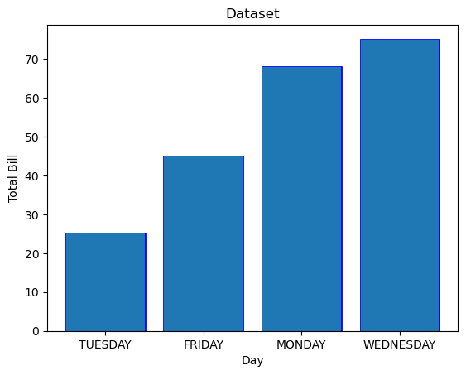

**1.2**

**import** matplotlib.pyplot **as** plt

import matplotlib.pyplot as plt

import pandas as pd

x = ['TUESDAY','FRIDAY','MONDAY','WEDNESDAY']

y = [25,45,68,75]

plt.bar(x, y, color='green', edgecolor='blue',

linewidth=2)

plt.title("Dataset")

plt.ylabel('Total Bill')

plt.xlabel('Day')

plt.show()

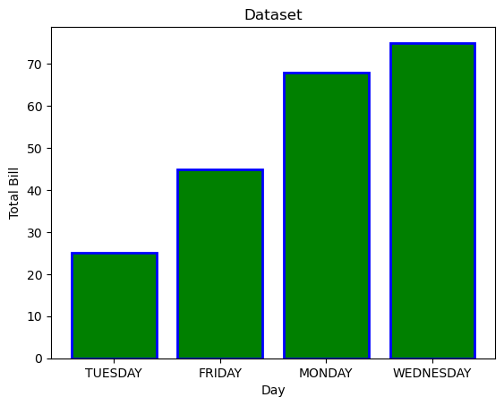

**2.1 HISTOGRAM CHART**

**import** matplotlib.pyplot **as** plt

**x=**[22, 87, 5, 43, 56, 73, 55, 54, 11, 20, 51, 5, 79, 31, 27]

plt**.**hist(x)

plt**.**title("Dataset")

plt**.**ylabel('Frequency')

plt**.**xlabel('Total Bill')

plt**.**show()

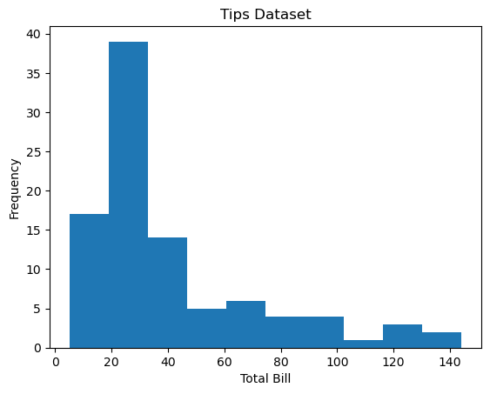

**2.2**

import matplotlib.pyplot as plt

**x=**[22, 87, 5, 43, 56, 73, 55, 54, 11, 20, 51, 5, 79, 31, 27]

plt.hist(x, bins=[0,20,40,60,80,100], color='green', edgecolor='blue',

linestyle='--')

plt.title("Dataset")

plt.ylabel('Frequency')

plt.xlabel('Total Bill')

plt.show()

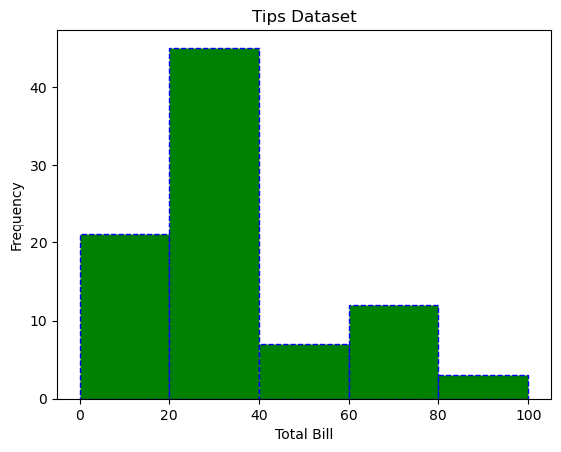

**3.1 PIE CHART**

**import** matplotlib.pyplot **as** plt

cars **=** ['AUDI', 'BMW', 'FORD',

'TESLA', 'JAGUAR',]

data **=** [23, 10, 35, 15, 12]

plt**.**pie(data, labels**=**cars)

plt**.**title("Car data")

plt**.**show()

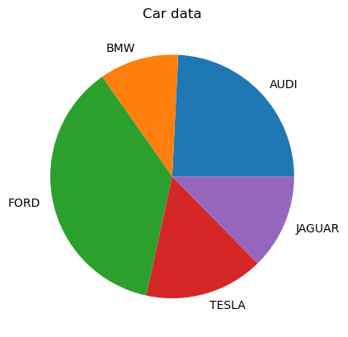

**3.2**

**import** matplotlib.pyplot **as** plt

cars **=** ['AUDI', 'BMW', 'FORD',

'TESLA', 'JAGUAR',]

data **=** [23, 13, 35, 15, 12]

explode **=** [0.1, 0.5, 0, 0, 0]

colors **=** ( "orange", "cyan", "yellow",

"grey", "green",)

plt**.**pie(data, labels**=**cars, explode**=**explode, autopct**=**'%1.2f%%',

colors**=**colors, shadow**=True**)

plt**.**show()

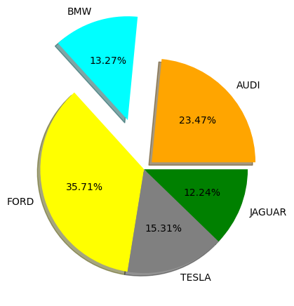

**4 SCATTER CHART**

import matplotlib.pyplot as plt

price = [2.50, 1.23, 4.02, 3.25, 5.00, 4.40]

sales = [34, 62, 49, 22, 13, 19]

plt.scatter(price, sales, c='RED', s=60,

marker='D', alpha=0.5)

plt.title("Dataset")

plt.ylabel('price')

plt.xlabel('sales')

plt.show()

plt.show()

